**International Business Final Report**

“American Factory”  
 Economic and Business Analysis

**By:**

**Challa Harshitha - 23CS01014  
Shrinivas Basanagouda Malipatil - 23EC01043  
Basva Jayanth - 23CS01010  
Kurapati Harshitha Sri - 23EC01025**

**Overview of the Film:**

"American Factory" (2019) is a documentary directed by Julia Reichert and Steven Bognar. The film, produced by Higher Ground Productions (the production company of Barack and Michelle Obama) and distributed by Netflix, offers an intimate, on-the-ground look at the cultural and economic clash between American and Chinese workforces in the context of globalization. The story revolves around a former General Motors (GM) factory in Dayton, Ohio, which was shuttered in 2008. Years later, in 2014, a Chinese company, Fuyao Glass America, a subsidiary of Fuyao Group, reopened the plant, repurposing it to manufacture automotive glass.

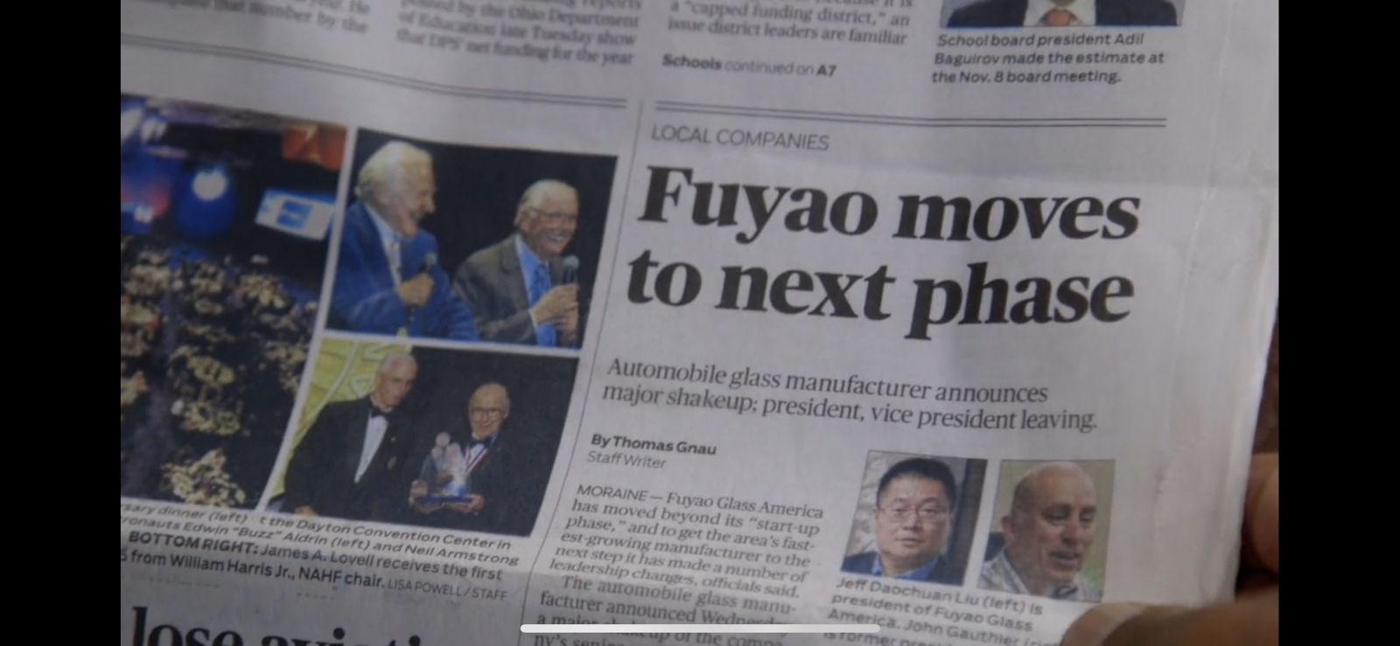The documentary captures a broader conversation about the effects of globalization, automation, and the economic tensions between labour costs, productivity, and international trade. This report analyzes the film’s core economic and business themes and evaluates its insights into contemporary manufacturing, labour relations, corporate strategy, and cross-cultural management.

**Economic Aspects:**

**1. Globalization and Economic Shifts**

"American Factory" is a case study of globalization in action. The 2008 closure of the GM plant in Dayton is emblematic of the broader decline of American manufacturing due to increased competition from overseas, particularly China, where labour costs were significantly lower. The film presents the reopening of the factory under Fuyao as a symbol of the shifting economic landscape, where foreign investment and multinational corporations play an increasing role in reviving dormant industries in the U.S.

However, the documentary underscores the challenges of globalization, particularly how differing economic models create friction. For Fuyao, bringing their Chinese management style and work ethic to an American workforce presented cultural and operational hurdles. The film highlights how these economic tensions manifest in issues related to productivity expectations, labour costs, and profit margins.

Fuyao’s decision to reopen the factory was motivated by a combination of factors:

* **Access to the U.S. market**: Producing glass locally in the U.S. helps avoid tariffs and transportation costs.
* **Utilization of existing infrastructure**: The old GM plant provided a pre-built industrial space that could be repurposed for glass manufacturing, reducing initial capital expenditure.

Fuyao’s investment also reflects China’s broader strategy of expanding its global economic footprint by investing in key industries and infrastructure around the world. In this case, China is not just exporting goods but exporting its industrial model and managerial practices.

**2. Labor Market Dynamics and Cost Differences**

The clash between American workers’ expectations for wages and working conditions and the Chinese company's profit-driven, high-productivity focus is central to the economic narrative of the film. Fuyao is able to offer significantly lower wages than what workers earned during the plant's GM era. The film shows workers being paid around $12 to $14 per hour, a substantial drop from the $29 per hour they earned when GM operated the facility.

This wage disparity is a key point of contention:

* From the workers' perspective, the wages are inadequate for maintaining a middle-class standard of living.
* From the company's perspective, these wages are necessary to keep production costs low in a globally competitive market.

Fuyao’s business model relies on its ability to keep costs down in order to remain competitive, especially against rivals from both the U.S. and China. While the company can utilise more affordable labour in its Chinese plants, it seeks to balance this by leveraging American labour and proximity to customers in the North American auto market. The trade-off between labour costs and productivity is a recurring theme in the documentary.

**3. Automation and Technological Investment**

One of the central economic tensions depicted in the film is the increasing role of automation in the factory. Fuyao initially employed many human workers to operate machines and handle tasks. However, as time goes on, the company increasingly turns to automation to boost efficiency and reduce reliance on human labour.

This shift toward automation is a microcosm of a broader economic trend:

* Automation reduces the need for low-skill labour, displacing workers who cannot easily transition to more skilled jobs.
* It leads to greater productivity, which is critical in keeping costs low and competing globally.

However, automation is also expensive and requires significant upfront capital investment. Fuyao, as a global company, has access to these resources, while many smaller manufacturers might not. This disparity highlights the growing divide between large multinational corporations and smaller, more localized businesses, many of which struggle to keep pace with technological change.

**Business Aspects:**

**1. Cross-Cultural Management and Organizational Culture**

The film exposes significant differences in organizational culture between the American workforce and Fuyao’s Chinese leadership. In many ways, this clash is a study in cross-cultural management:

* **Chinese work culture**: Emphasizes long hours, discipline, loyalty to the company, and a top-down management approach.
* **American work culture**: Focuses on individualism, a more collaborative approach, and a stronger emphasis on work-life balance.

The factory’s American workers struggled to adapt to the expectations set by the Chinese management, which included working long hours with few breaks and an unrelenting focus on output. Meanwhile, Chinese managers were often frustrated with what they saw as a lack of discipline and a sense of entitlement among American workers. This cultural clash was exacerbated by language barriers and the limited understanding each side had of the other's expectations and values.

Fuyao’s approach to management highlights broader business challenges related to the globalization of labour:

* **Management style adaptation**: While some aspects of Chinese management practices were effective in China, they were less successful in the U.S. Fuyao’s struggle reflects a failure to fully adapt their business practices to local cultural norms.
* **Employee engagement**: The film shows that morale among American workers was low, in part due to a perception that their voices were not being heard by the Chinese leadership. This is in stark contrast to the more collectivist Chinese approach, where dissent and questioning of authority are less common.

**2. Unionization and Labor Relations**

A central conflict in "American Factory" is the struggle over unionization. American workers at Fuyao attempted to organize under the United Auto Workers (UAW) to push for better wages and working conditions. Fuyao management, on the other hand, strongly opposes unionization, seeing it as a threat to profitability and operational flexibility.

The business implications of unionization are complex:

* **From the company’s perspective**: Unionization could increase labor costs and reduce their ability to implement changes quickly. The film captures Fuyao’s anti-union campaign, which includes bringing in consultants and holding meetings to persuade workers that a union would hurt the company’s competitiveness and their jobs.
* **From the workers’ perspective**: Unionization offers the hope of better wages, benefits, and working conditions. The UAW promises to restore some of the gains lost since the plant's GM days.

The film reflects the broader decline of union power in the U.S., particularly in manufacturing industries. While union membership once protected workers from the worst excesses of corporate cost-cutting, many companies today (especially those with global operations) resist unions, arguing that they reduce flexibility and add costs that make businesses less competitive in a global market.

**3. Global Supply Chains and Logistics**

Fuyao’s investment in the Dayton plant is part of a broader strategy to build a global supply chain that spans multiple continents. By manufacturing glass in the U.S., Fuyao reduces shipping costs and can more quickly respond to customer needs, particularly major automakers like General Motors, Ford, and Chrysler.

This highlights a broader business trend:

* Companies are increasingly seeking to localize production as part of their supply chain strategy, even if it means investing in higher-cost regions like the U.S. This is particularly true for industries with high transportation costs or just-in-time manufacturing models.
* 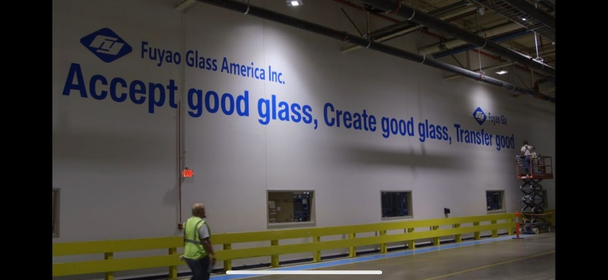The trade-offs between localizing production and maintaining a global supply chain are a key consideration for multinational corporations. While Fuyao is able to produce glass in the U.S. for North American customers, they still rely on their global network of factories and suppliers for other parts of their operation.

**Conclusion:**

"American Factory" provides a nuanced and thought-provoking analysis of the economic and business forces that shape today’s global economy. Through the lens of one factory in Dayton, Ohio, the film explores the tensions between globalization, automation, labour relations, and cultural differences that impact businesses worldwide.

From an economic perspective, it highlights the competitive pressures that drive companies to seek out lower labour costs and greater efficiency, often at the expense of workers' wages and job security. The film also showcases the role of automation in reshaping industries, as companies balance the need for human labour with the benefits of new technologies.

On the business side, the documentary underscores the challenges of cross-cultural management and the difficulties of maintaining employee morale and productivity in a globalized world. The struggle over unionization serves as a reminder of the ongoing debates about workers' rights and the role of organised labour in a rapidly changing economy.

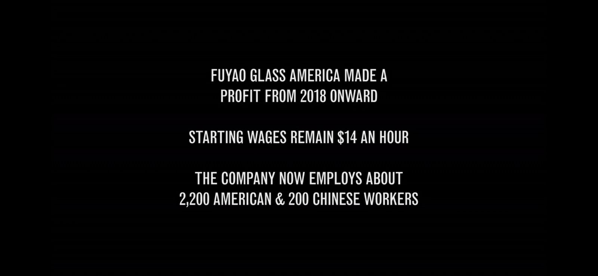Ultimately, "American Factory" is a powerful reminder that the global economy is as much about people as it is about profits and that the future of work will require balancing the demands of both in new and innovative ways.